Create a GitHub account
- Go to github website
- Click on create account

Set up MFA (Multi-Factor Authentication) for the GitHub account using a mobile app.
- go to the github portal
- search for settings
- click on settings
- select password and authentication
- click on enable two factor authentication
- then add your number and will get one otp to verify your number
- then it will successfully add the mobile number and enable the two factor authentication
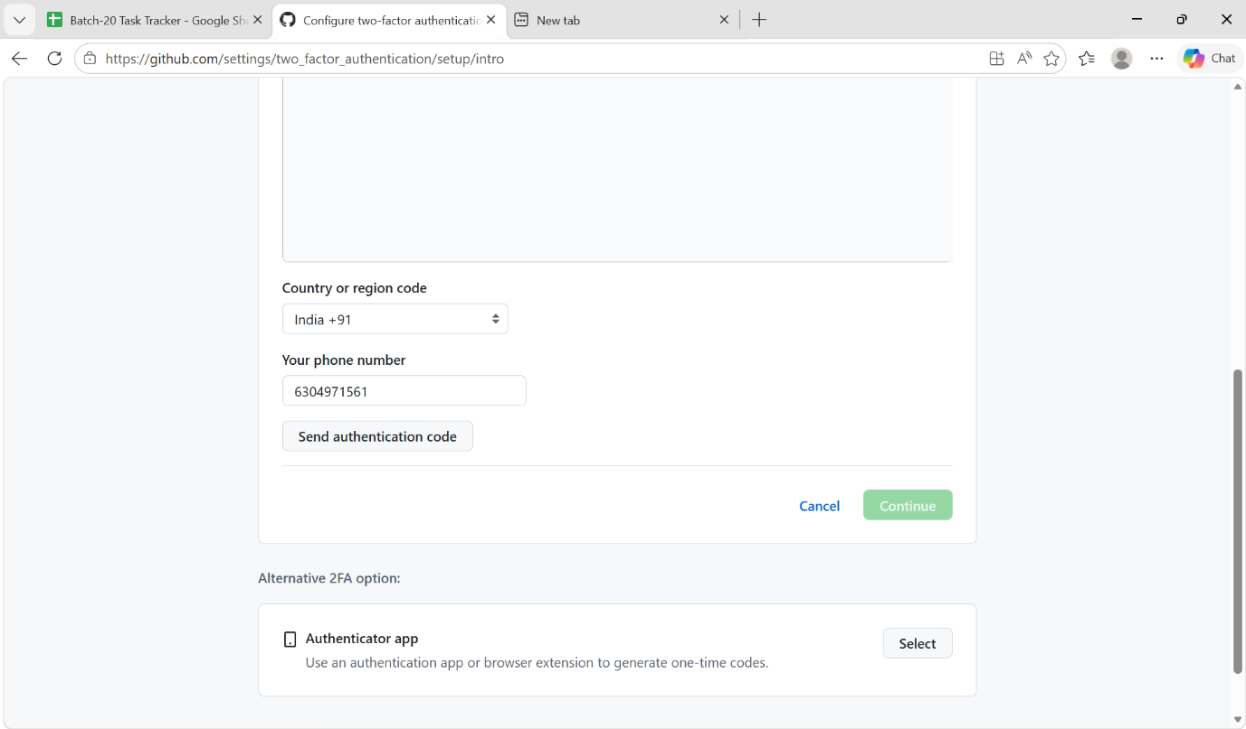
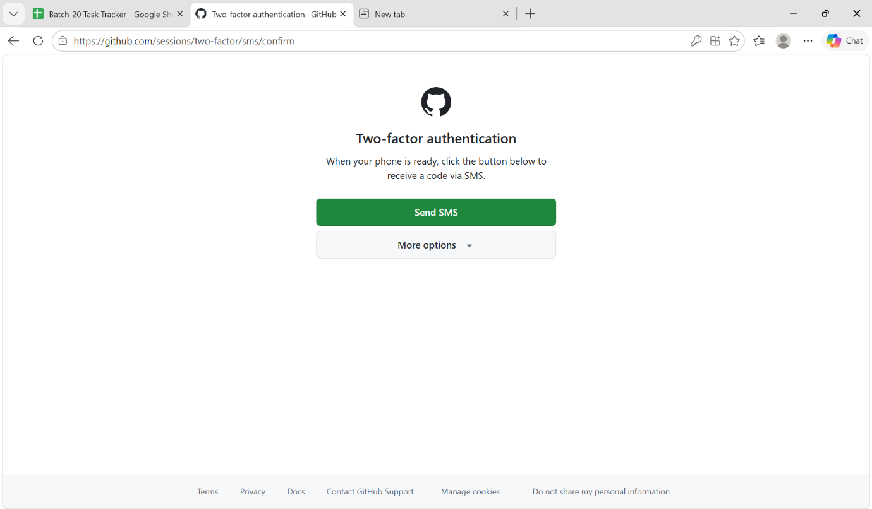

Commands that have shown in the video

- First of all we have to initiate the git by the command -> git init

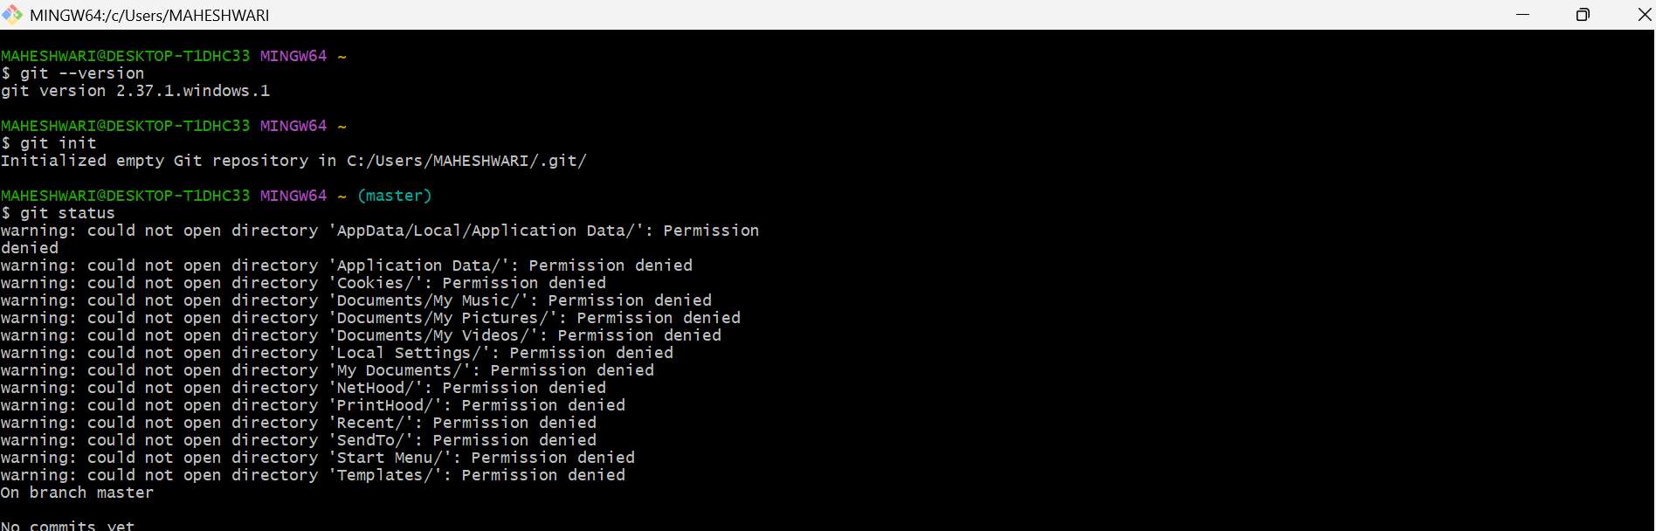

- To configure the username and email -> git config
- To add a username -> git config –global user.name “maheshwari”
- To add a email to the username -> git config –global user.email “emailed”

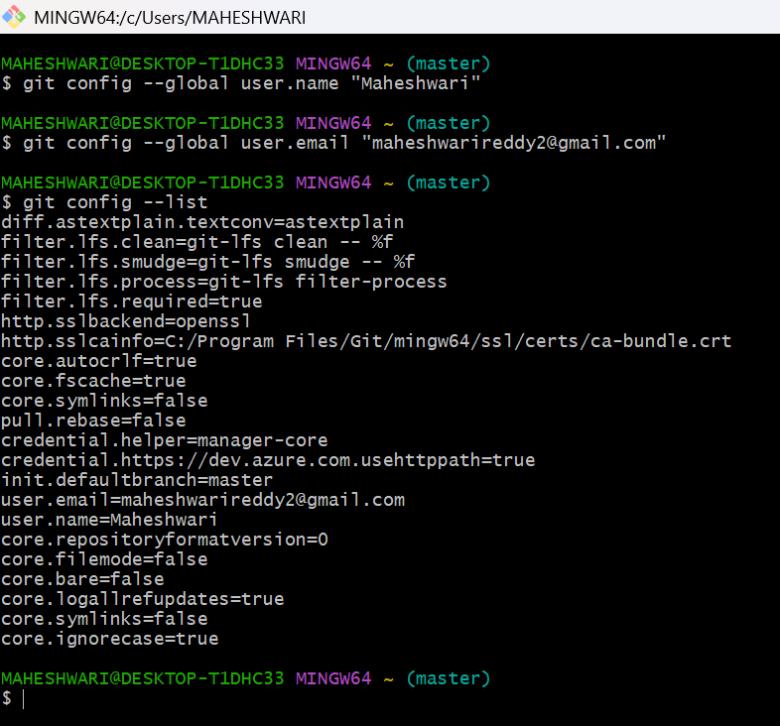

- Create files and move the created file from untracking area to tracking area by using the command -> git add .

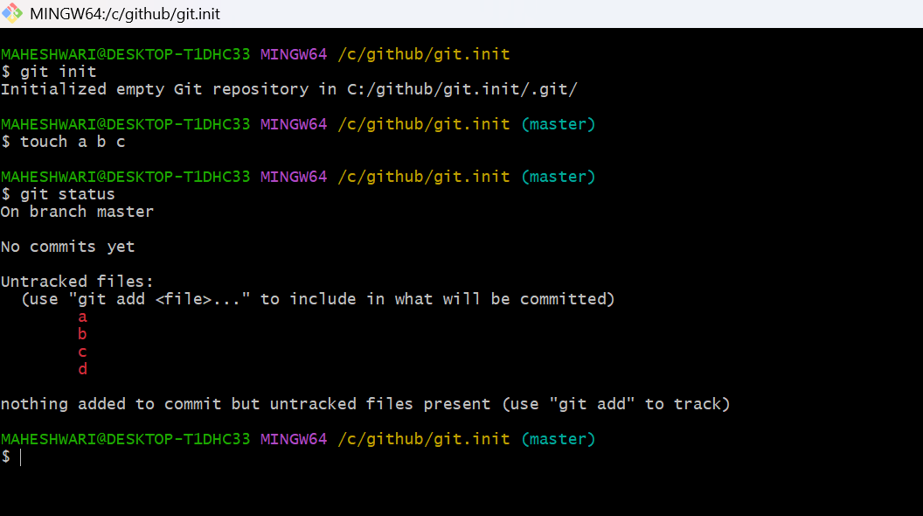

- And commit the tracking files & it creates a commit id for every commit and it will be unique -> git commit

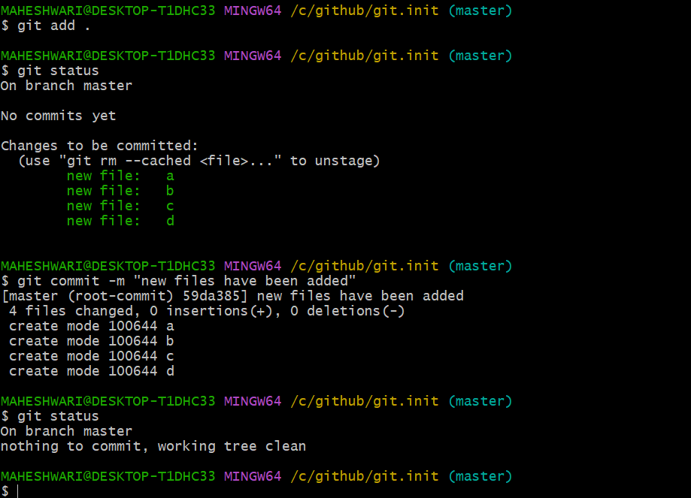

- To check the status of the commited files -> git status

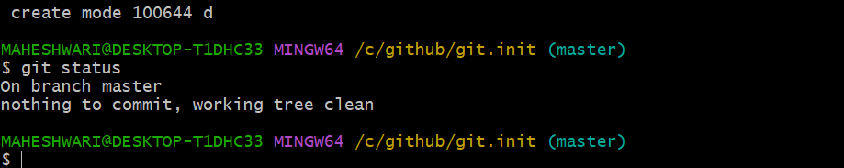

- Create a github repo in the portal with the unique name

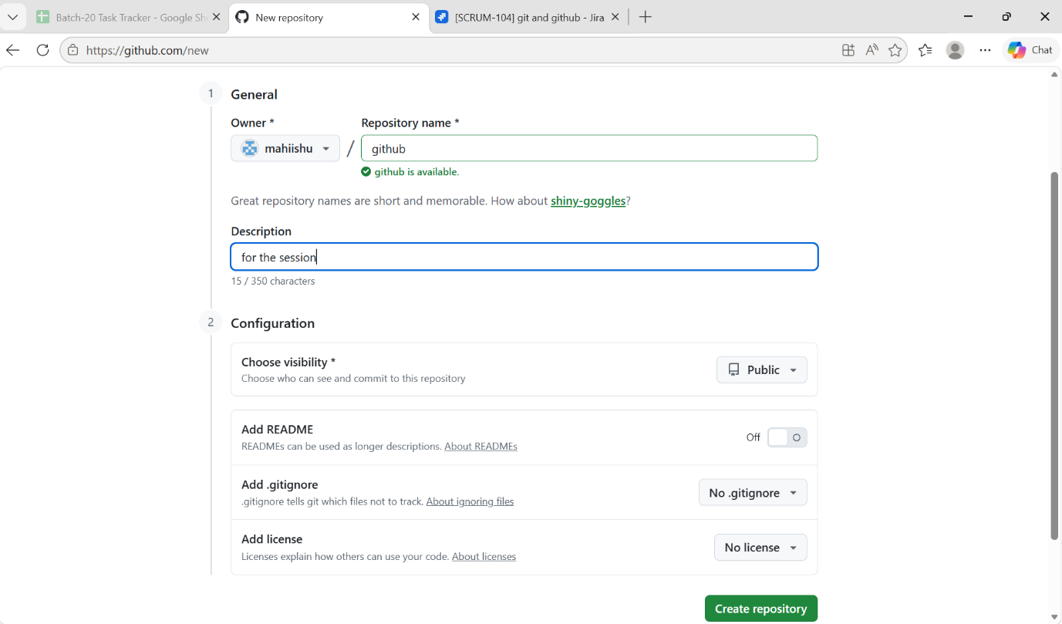

- Add the ssh path of github repo to push the files
- git remote -v -> to check the destination address is there or not
- If not there the add the remote repo -> git remote add origin git@github.com:mahiishu/github.git

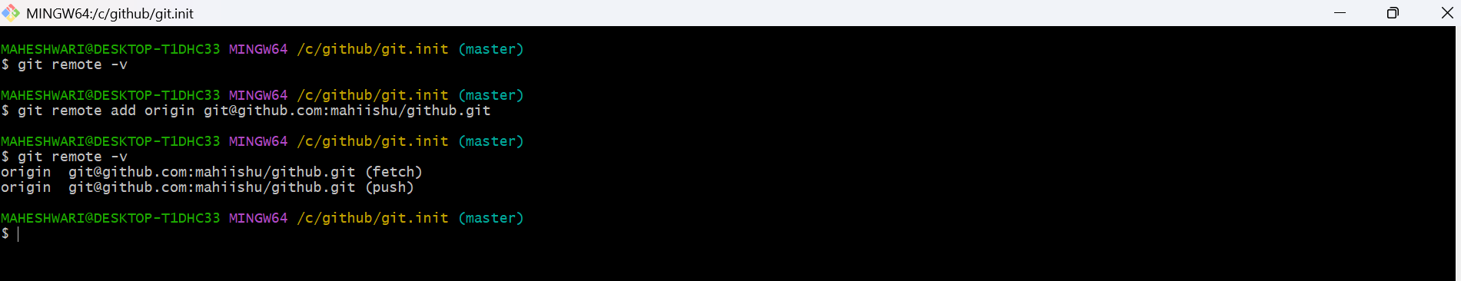

- To push this to github repo firstly we have set up ssh key in the github portal
- Ssh key is generated by the command -> ssh-keygen

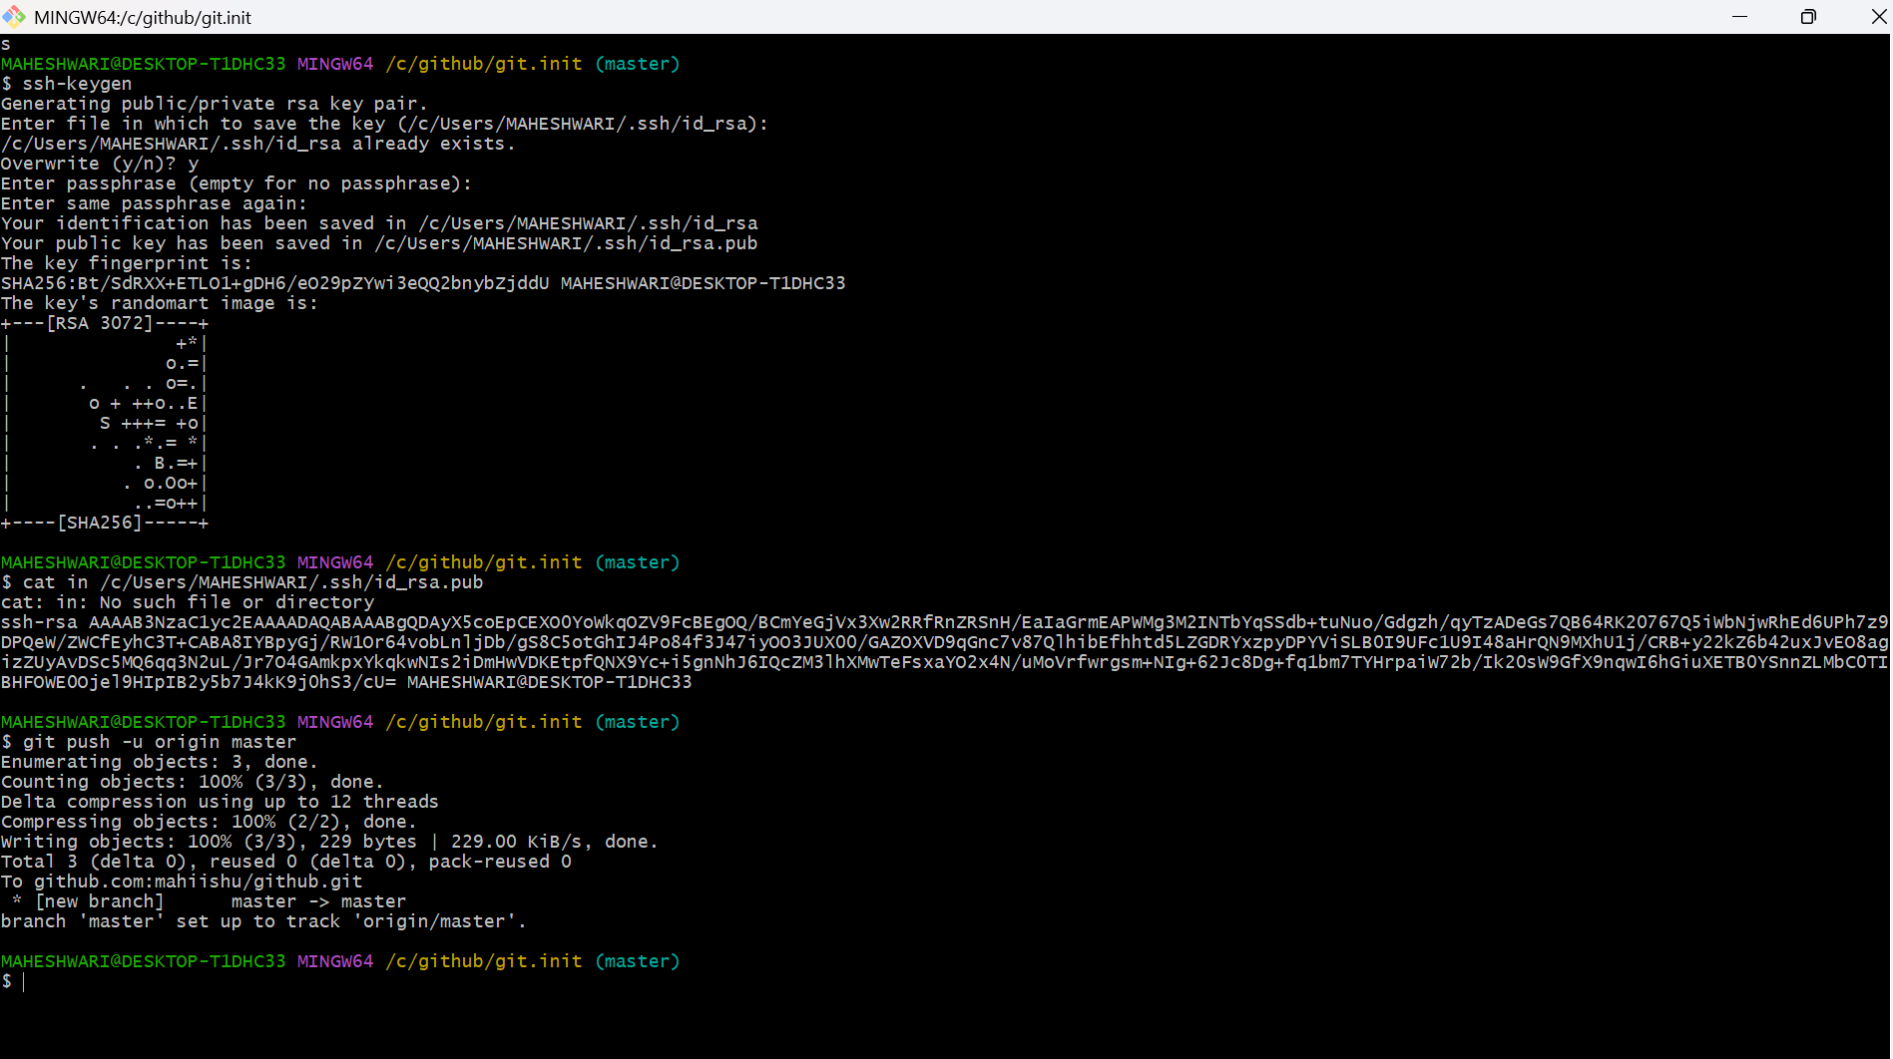

- It gives two key one is private and one is public
- Public key have to be added in the ssh key authentication
- To push the code from local machine to github repo ->
git push -u origin master

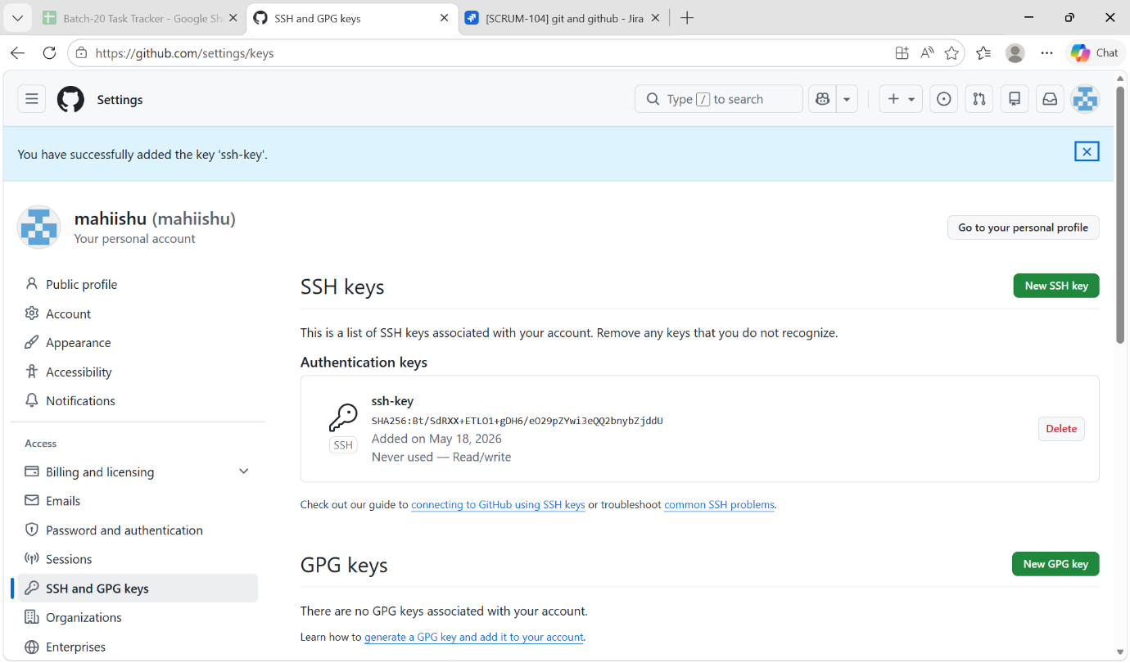

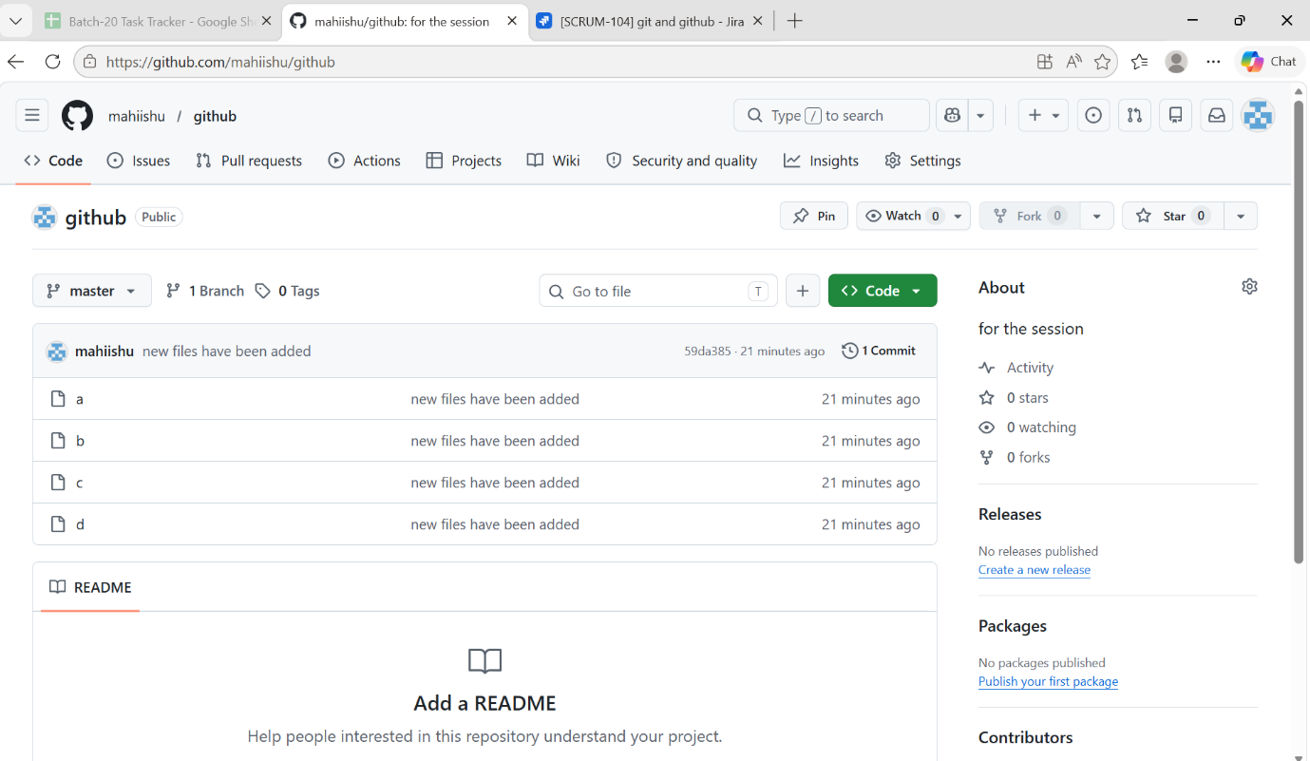

- Delete one file from repo in our local and commit the change it will delete the file

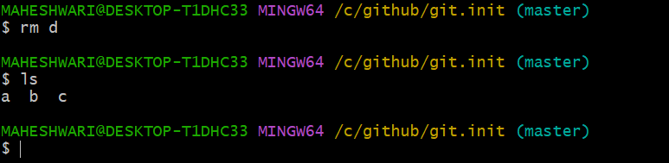
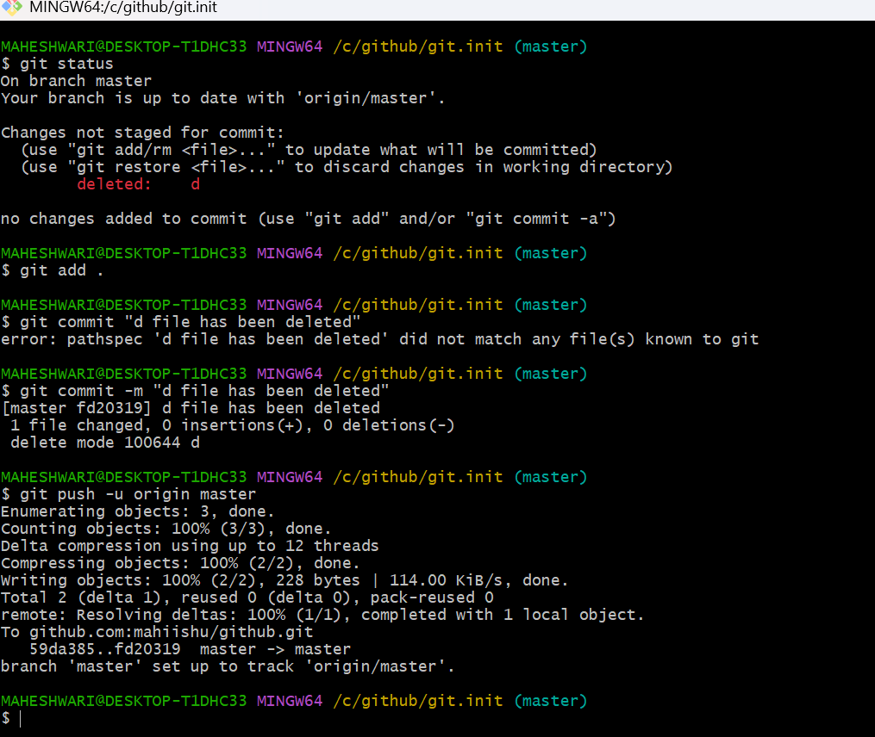

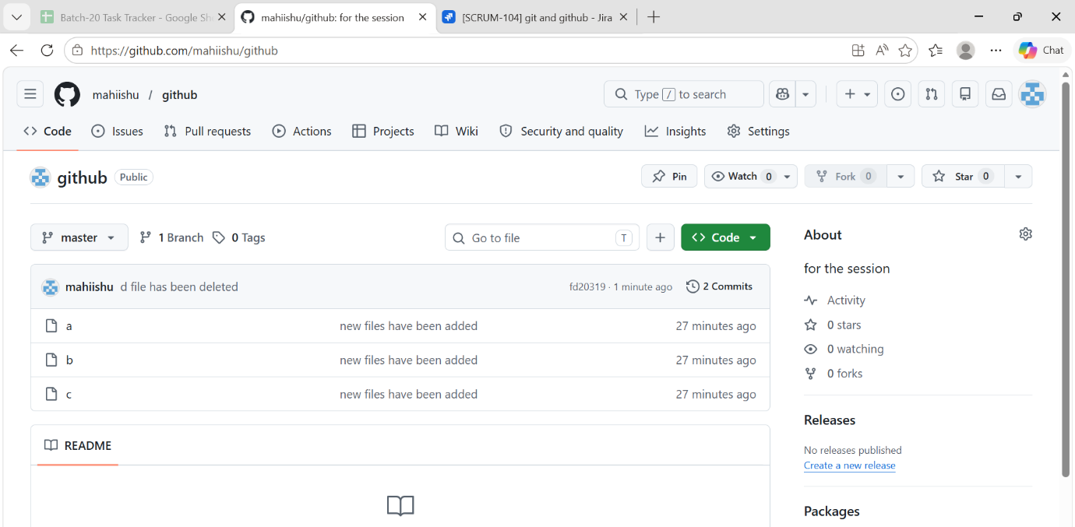

- Create a file in the github repo directly and one in our local machine and then commit the file in our local machine, try to push it to the github repo it will not take the update because in github repo we have created a file but we don’t have that file in our local.
- So first pull the updates from the repo then commit the changes again and then push the update to the github repo
- git pull -> pull only the updated of the repo
- git clone -> pull the complete folder that means the repo
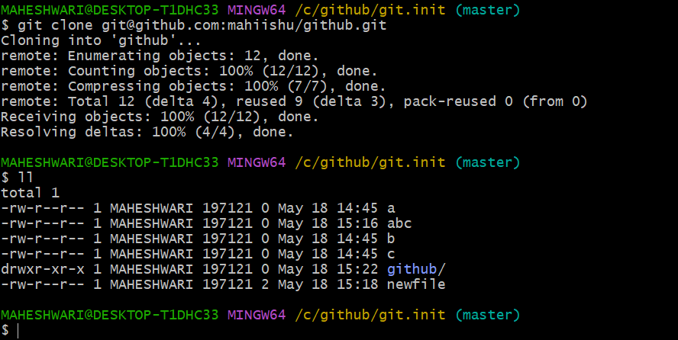

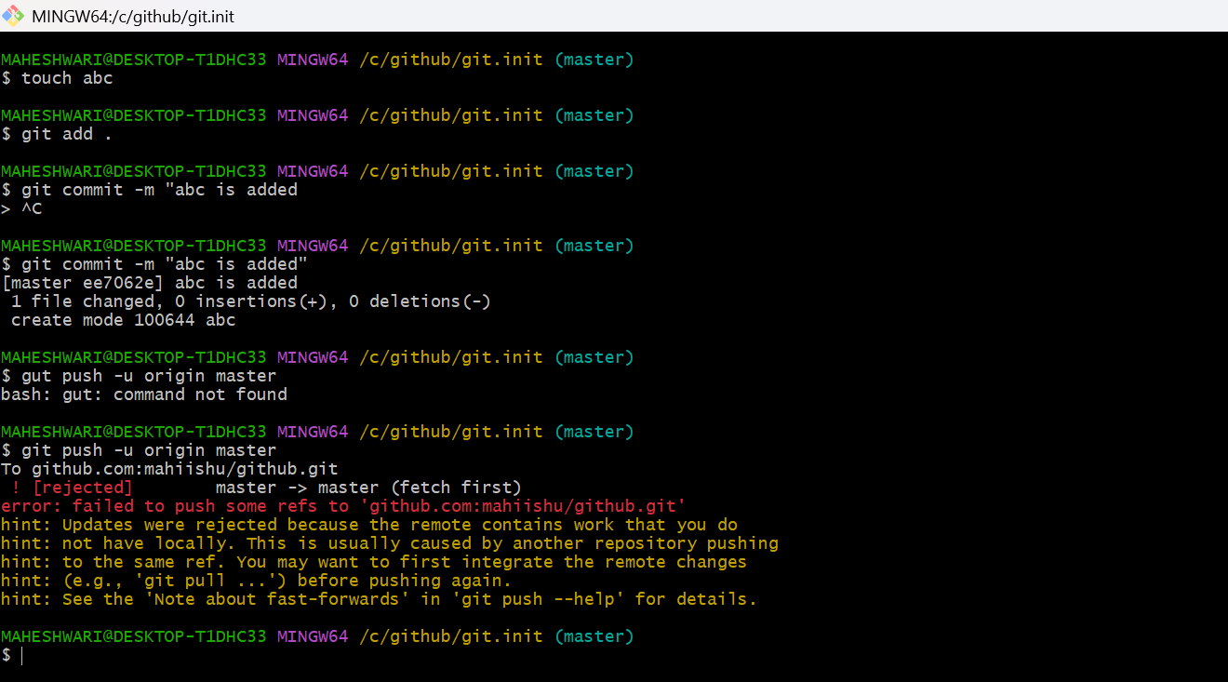

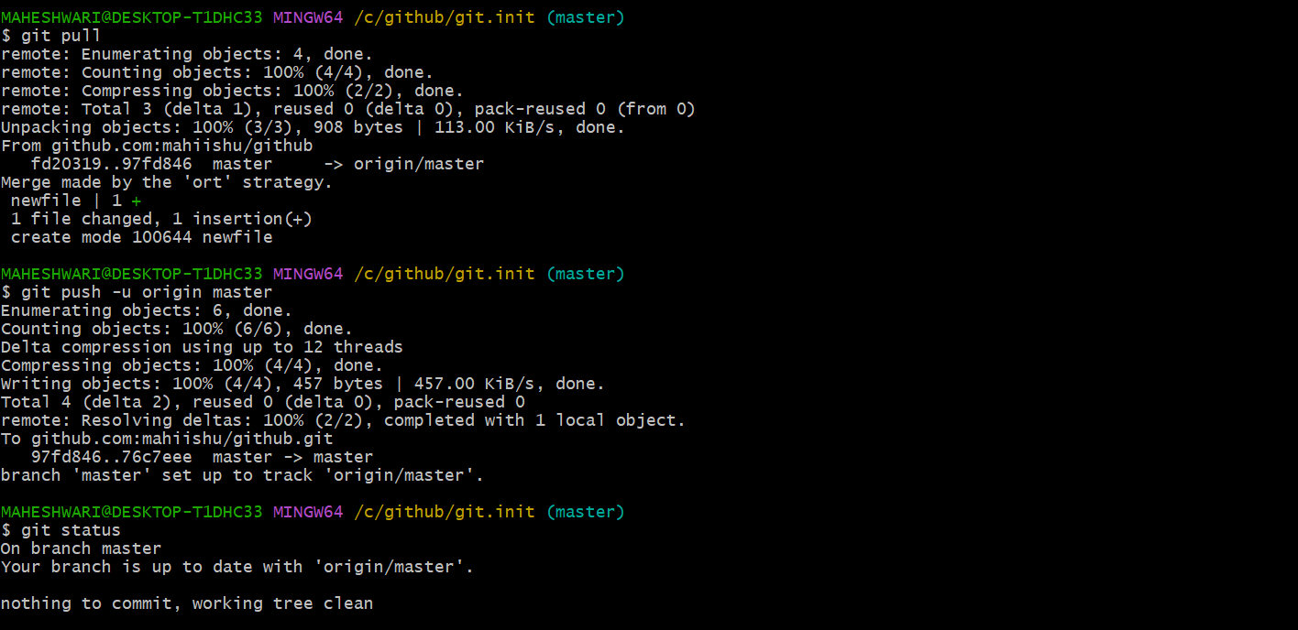

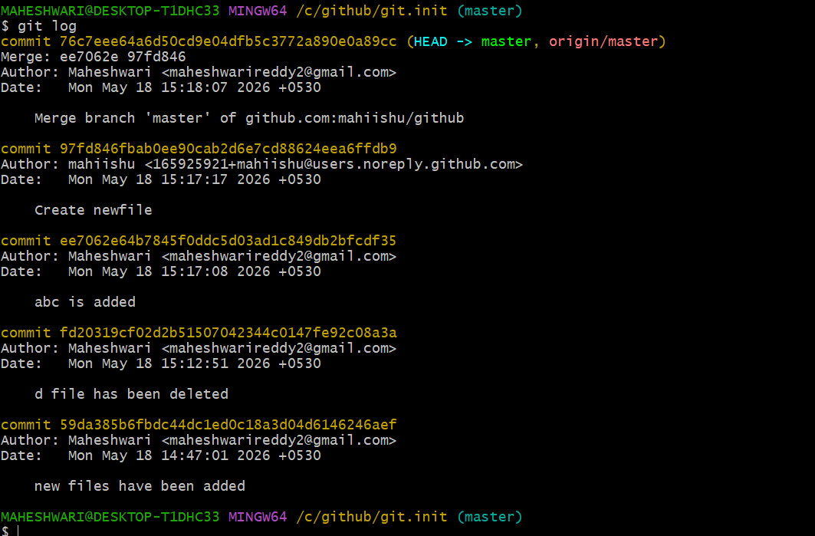

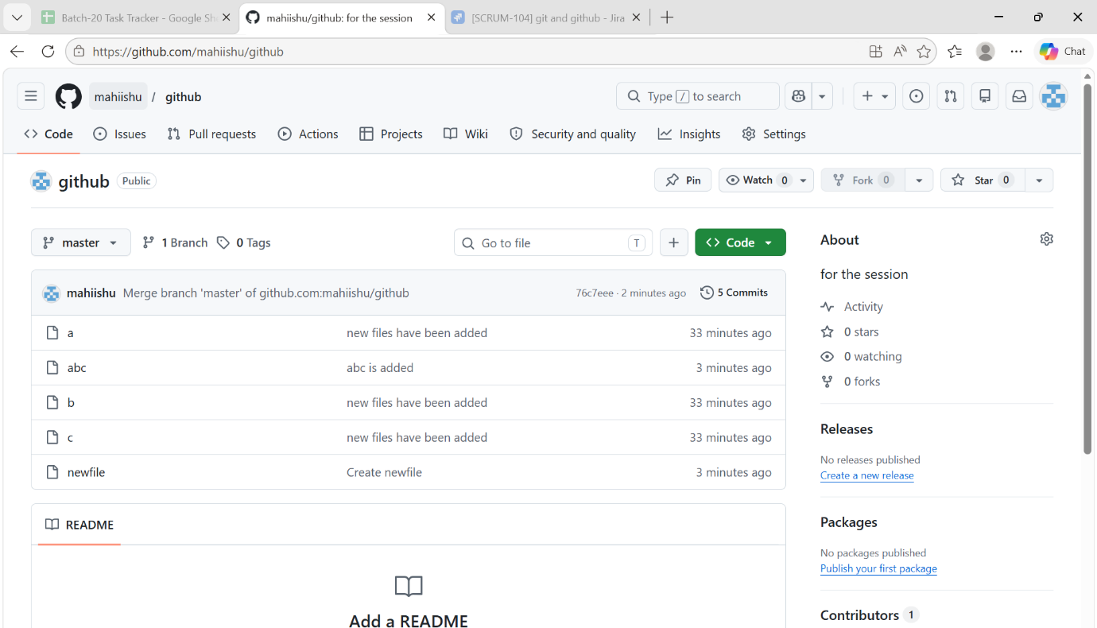

- to get the deleted files -> git revert <commitid>
- get the commitid by the command -> git log
- and then push the file to the github repo
- 